## Ecommerce Customer Churn Analysis and Prediction:

RF:

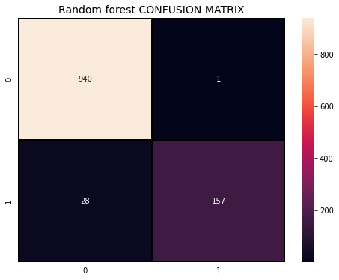

LR:

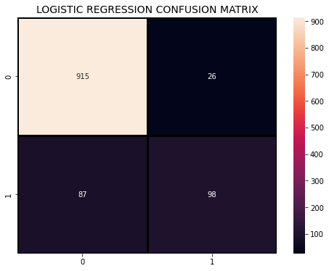

|  |  |  |  |  |
| --- | --- | --- | --- | --- |
|  | Accuracy | Precision | Recall | F1 score |
| Random forest | 0.9742 | 0.9989 | 0.9711 | 0.9848 |
| Logistic Regression | 0.8996 | 0.9724 | 0.9132 | 0.9418 |

Lightgbm:

Light GBM Classifier 0.9698046181172292

              precision    recall  f1-score   support

           0       0.97      0.99      0.98       941

           1       0.95      0.86      0.90       185

    accuracy                           0.97      1126

   macro avg       0.96      0.93      0.94      1126

weighted avg       0.97      0.97      0.97      1126

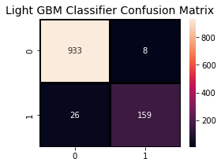

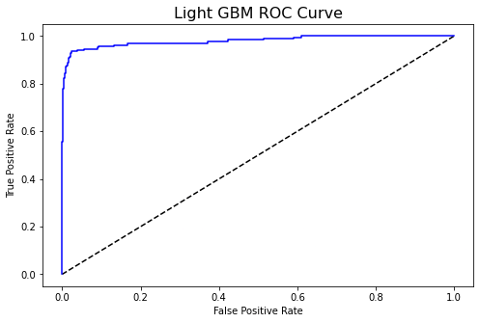

XGBoost:

XGBoost Classifier 0.977797513321492

              precision    recall  f1-score   support

           0       0.98      0.99      0.99       941

           1       0.97      0.90      0.93       185

    accuracy                           0.98      1126

   macro avg       0.97      0.95      0.96      1126

weighted avg       0.98      0.98      0.98      1126

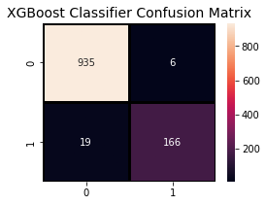

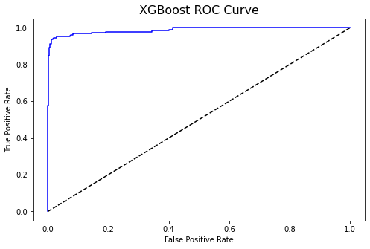

KNN:

K-Nearest Neighbors Classifier 0.8747779751332149

              precision    recall  f1-score   support

           0       0.90      0.96      0.93       941

           1       0.67      0.46      0.55       185

    accuracy                           0.87      1126

   macro avg       0.79      0.71      0.74      1126

weighted avg       0.86      0.87      0.87      1126

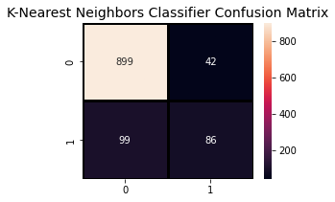

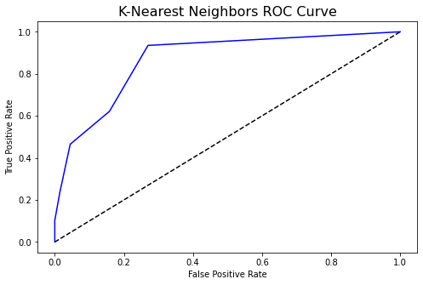

Svm

SVM accuracy is : 0.8357015985790408

------------------------------------------------------------

              precision    recall  f1-score   support

           0       0.84      1.00      0.91       941

           1       0.00      0.00      0.00       185

    accuracy                           0.84      1126

   macro avg       0.42      0.50      0.46      1126

weighted avg       0.70      0.84      0.76      1126

------------------------------------------------------------

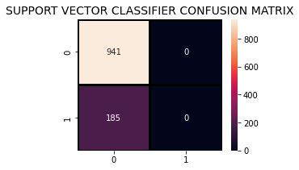

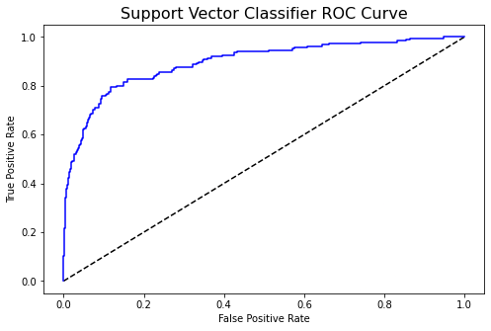

Decision Tree Classifier

Decision Tree Classifier 0.9626998223801065

              precision    recall  f1-score   support

           0       0.98      0.97      0.98       941

           1       0.87      0.90      0.89       185

    accuracy                           0.96      1126

   macro avg       0.93      0.94      0.93      1126

weighted avg       0.96      0.96      0.96      1126

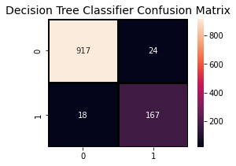

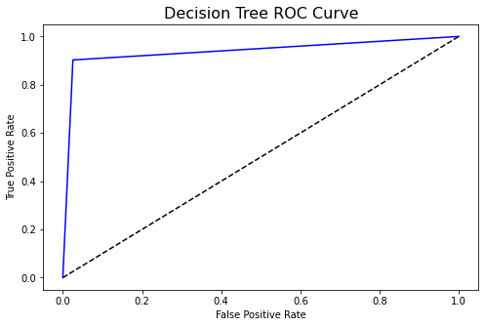

|  |  |  |  |  |  |
| --- | --- | --- | --- | --- | --- |
| Algorithms | Accuracy | Precision | Recall | F1 Score | MCC |
| Random Forest | 0.9742 | 0.9989 | 0.9711 | 0.9848 | 0.904 |
| Logistic Regression | 0.8996 | 0.9724 | 0.9132 | 0.9418 | 0.589 |
| SVM | 0.83 | 1.0000 | 0.8357 | 0.9105 |  |
| KNN | 0.87 | 0.95 | 0.90 | 0.92 | 0.49 |
| Decision tree | 0.96 | 0.97 | 0.98 | 0.97 | 0.86 |
| XGboost | 0.97 | 0.99 | 0.98 | 0.98 | 0.91 |
| LightGBM | 0.96 | 0.99 | 0.97 | 0.98 | 0.88 |